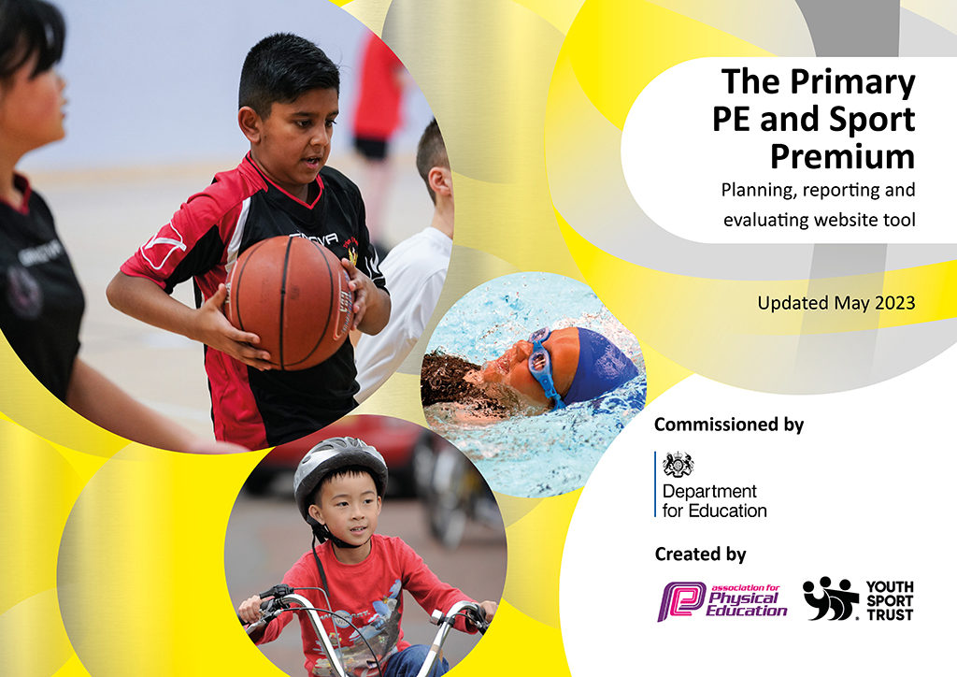
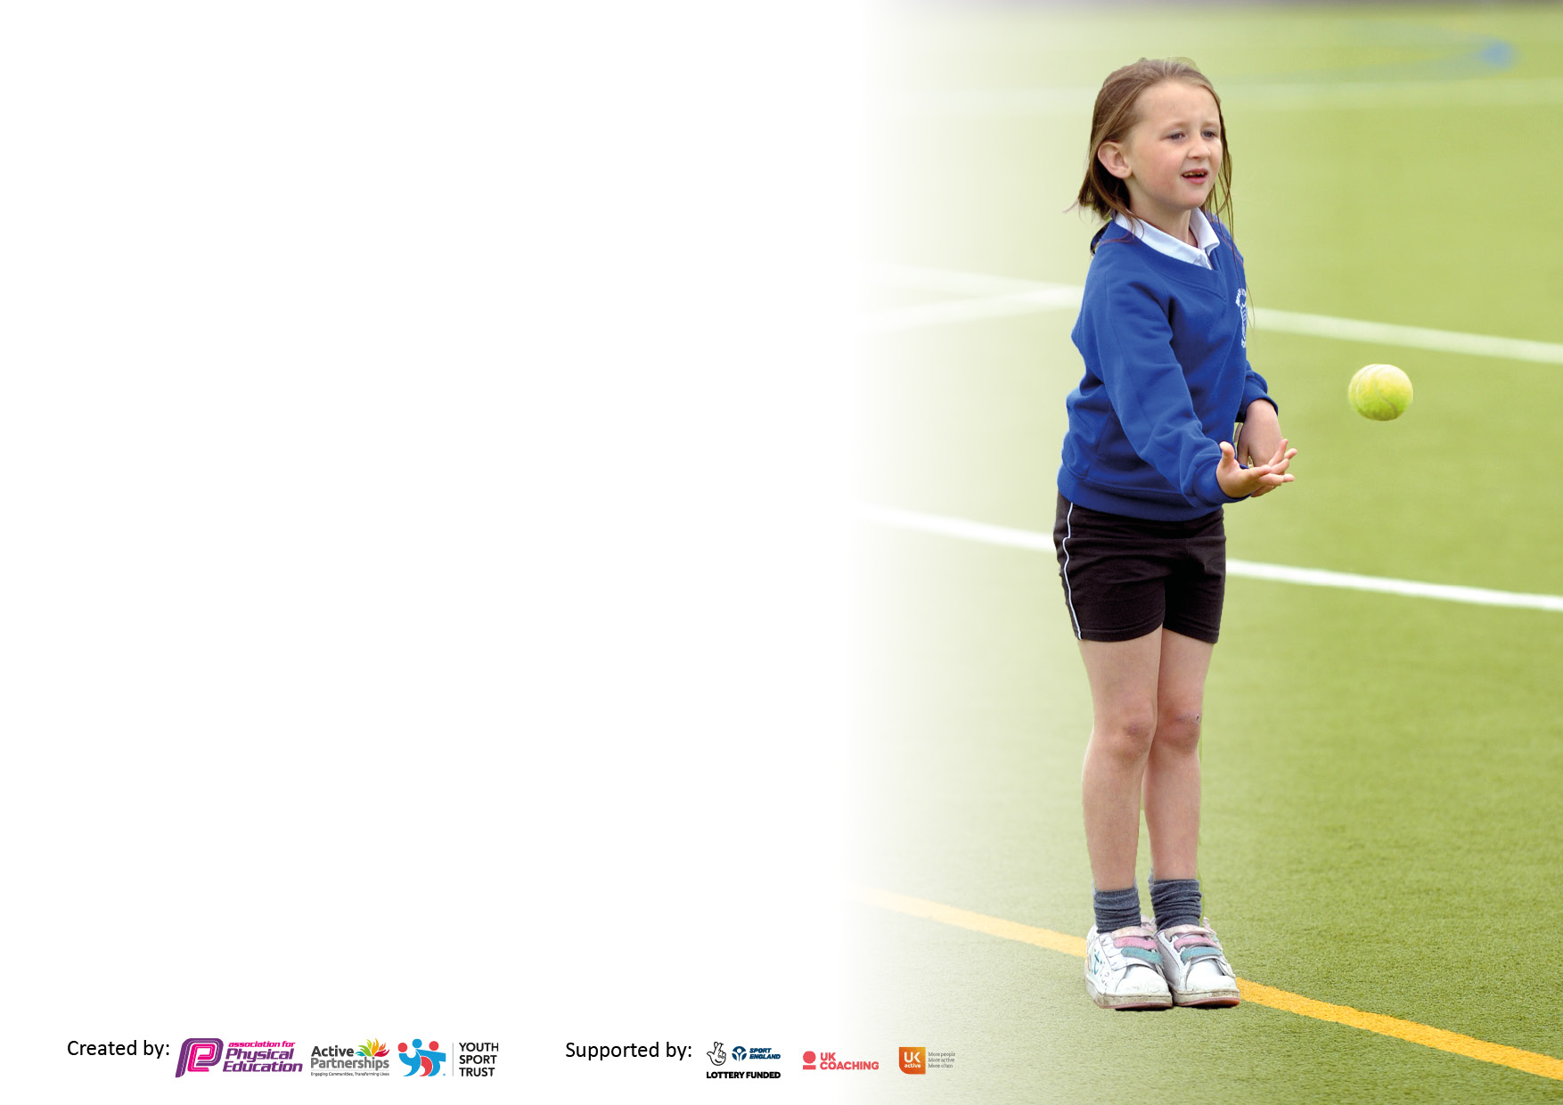

It is important that your grant is used effectively and based on school need. The Education Inspection Framework makes clear there will be a focus on ‘whether leaders and those responsible for governors all understand their respective roles and perform these in a way that enhances the effectiveness of the school’.

Under the Quality of Education Ofsted inspectors consider:
Intent - Curriculum design, coverage and appropriateness
Implementation - Curriculum delivery, Teaching (pedagogy) and Assessment
Impact - Attainment and progress

To assist schools with common transferable language this template has been developed to utilise the same three headings which should make your plans easily transferable between working documents.

Schools must use the funding to make additional and sustainable improvements to the quality of Physical Education, School Sport and Physical Activity (PESSPA) they offer. This means that you should use the Primary PE and sport premium to:

- Develop or add to the PESSPA activities that your school already offer
- Build capacity and capability within the school to ensure that improvements made now will benefit pupils joining the school in future years
- The Primary PE and sport premium should not be used to fund capital spend projects; the school’s budget should fund these.

Please visit gov.uk for the revised DfE guidance including the5keyindicatorsacrosswhichschoolsshoulddemonstrate an improvement. This document will helpyoutoreviewyourprovisionandtoreportyourspend.DfEencouragesschools to use this template as an effective way of meeting the reporting requirements of the Primary PE and Sport Premium.

We recommend you start by reflecting on the impact of current provision and reviewing the previous spend.

Schools are required to publish details of how they spend this funding, including any under-spend from 2021/2022, as well as on the impact it has on pupils’ PE and sport participation and attainment. The funding should be spent by 31st July but the DfE has stated that there will be no clawback of any unspent money so this can be carried forward into 2023/24.

We recommend regularly updating the table and publishing it on your website throughout the year. This evidences your ongoing self-evaluation of how you are using the funding to secure maximum, sustainable impact. Final copy must be posted on your website by the end of the academic year and no later than the 31st July 2023. To see an example of how to complete the table please click HERE.

Details with regard to funding
Please complete the table below.

Total amount allocated for 2023/24 | £ 19000
Total amount of funding for 2023/2024. Ideally should be spent and reported on by 31st July 2024 | £ 19022
Swimming Data
Please report on your Swimming Data below.

Meeting national curriculum requirements for swimming and water safety.  N.B. Complete this section to your best ability. For example you might have practised safe self-rescue techniques on dry land which you can then transfer to the pool when school swimming restarts.  Due to exceptional circumstances priority should be given to ensuring that pupils can perform safe self rescue even if they do not fully meet the first two requirements of the NC programme of study | 39%
What percentage of your current Year 6 cohort swim competently, confidently and proficiently over a distance of at least 25 metres?  N.B. Even though your pupils may swim in another year please report on their attainment on leaving primary school at the end of the summer term 2023.  Please see note above | 64%
What percentage of your current Year 6 cohort use a range of strokes effectively [for example, front crawl, backstroke and breaststroke]?  Please see note above | 31%
What percentage of your current Year 6 cohort perform safe self-rescue in different water-based situations? | 23%
Schools can choose to use the Primary PE and sport premium to provide additional provision for swimming but this must be for activity over and above the national curriculum requirements. Have you used it in this way? | Yes

Action Plan and Budget Tracking
Capture your intended annual spend against the 5 key indicators. Clarify the success criteria and evidence of impact that you intend to measure to evaluate for pupils today and for the future.

Academic Year: 2023/24 | Total fund allocated:19022 | Date Updated: October 2024
Key indicator 1: The engagement of all pupils in regular physical activity – Chief Medical Officers guidelines recommend that primary school pupils undertake at least 30 minutes of physical activity a day in school |  |  |  | Percentage of total allocation:
Intent | Implementation |  | Impact
Your school focus should be clear what you want the pupils to know and be able to do and about  what they need to learn and to  consolidate through practice: | Make sure your actions to achieve are linked to your intentions: | Funding allocated: | Evidence of impact: what do pupils now know and what can they now do? What has changed?: | Sustainability and suggested next steps:
 | Clear timetables and PE sessions for each class each day  Planning and support available for new staff  Monitor staff skills/knowledge through use of pupil voice and QA cycle  Monitor lessons and quality of learning and teaching within PE | SPIN coach additional day  SPIN  £3812 | Timetables will be set and monitor provides evidence that physical activity is being completed daily by all children  Baselines of basic skills completed starting at Y3 to ensure teaching to meet needs of pupils and progression from right starting points  Children will feedback positively about their physical activity programme  All children can take part in PE with PE kit  SIMs and CPOMs behaviour analysis will show a reduction in disruption in lessons from identified vulnerable groups ( SEN (SEMH) boys) | Identify vulnerable/target group as case study of impact – develop focussed PE activity groups to address child obesity/inaction/reluctant girls  1k-a-day firmly embedded in school day.
Key indicator 2: The profile of PESSPA being raised across the school as a tool for whole school improvement |  |  |  | Percentage of total allocation:
Intent | Implementation |  | Impact
Your school focus should be clear what you want the pupils to know and be able to do and about  what they need to learn and to  consolidate through practice: | Make sure your actions to achieve are linked to your intentions: | Funding allocated: | Evidence of impact: what do pupils now know and what can they now do? What has changed?: | Sustainability and suggested next steps:
Pupils to experience high quality PE and Sport by ‘up skilling’ staff in PE subject specific knowledge  Provide extra-curricular clubs and inter school competition events for every year group throughout year  House assembly and competitions linking to PE, celebrating achievements. | House system linked to PE events  All teachers providing high quality curriculum for all pupils  All teachers to attend/support PE lead with extra-curricular/competition event  Monitoring of PE within QA cycle  CPD planned into school CPD calendar  SPIN events across the year to engage children in competitive events and increased day from coach and G&T tournaments and festivals | Coach and CPD  £8970  SPIN membership | 2 termly House PE events completed  QA monitoring evidence of standards of learning and teaching  CLICK milestone analysis shows increase in % of children achieving NC statements in PE  2 PE planned CPD events - teacher feedback and evaluation is positive and constructive  Displays celebrate PE across school and evidence skills and knowledge developed by children  House Captains/SSOC (School Sports Organising Crew) to assist MT with planning and running of events  Staff CPD, visit events or extra curricular clubs for pupils will be attended | CPD calendar planning with PE coordinator  Identify NC statements and analysis tool to use for subject progression documents  Ensure teacher feedback taken from CPD events - leads into next planned CPD session  Pupil voice and celebration of developments - good practice? What are other schools doing?  MT/LC to hold half termly meetings with House Captains

Key indicator 3: Increased confidence, knowledge and skills of all staff in teaching PE and sport |  |  |  | Percentage of total allocation:
 |  |  |  | %
Intent | Implementation |  | Impact
Your school focus should be clear | Make sure your actions to | Funding | Evidence of impact: what do | Sustainability and suggested
what you want the pupils to know | achieve are linked to your | allocated: | pupils now know and what | next steps:
and be able to do and about | intentions: |  | can they now do? What has
what they need to learn and to |  |  | changed?:
consolidate through practice:
In order to improve progress and achievements of all pupils the focus is on up-skilling the staff. | LC to lead and then assist class teachers in PE lessons – planning shared and adapted together to meet needs of pupils  MT to assist class teachers with planning/teaching where needed  Baseline pupils so that impact can be measured over time | BTP/LC costs  SPIN support | Better subject knowledge for teachers and TA’s, with the latter being more confident to take a more active role in lessons  Increased confidence and better subject leadership skills enabling the subject leader to lead professional learning for all staff  Subject leader more confident when undertaking lesson observations/team teaching – able to provide effective feedback and lead discussions.  WIDER IMPACT AS A RESULT OF ABOVE  - Skills, knowledge and understanding of pupils are increased significantly  - Pupils really enjoy PE and Sport, are very keen to take part and demonstrate a real desire to learn and improve | MT to carry out informal drop-ins – teacher confidence questionnaire  LC coaches feedback on lessons  Subject lead to attend network and SPIN meetings and feedback to staff
Key indicator 4: Broader experience of a range of sports and activities offered to all pupils |  |  |  | Percentage of total allocation:
 |  |  |  | 6%
Intent | Implementation |  | Impact
Your school focus should be clear | Make sure your actions to | Funding | Evidence of impact: what do | Sustainability and suggested
what you want the pupils to know | achieve are linked to your | allocated: | pupils now know and what | next steps:
and be able to do and about | intentions: |  | can they now do? What has
what they need to learn and to |  |  | changed?:
consolidate through practice:
Specialist PE teacher/coach providing children with a variety of sports and activities at a high standard  Extra curricular programme is broad and offers variety to each year group throughout school year | Map across KS2 sports/games taught in each term – skills progression focus  Liaise closely with Coach to develop and extend activities provided after school – listening to pupil voice and adapting clubs  Review and evaluate planning each term and adapt to improve - include pupil and teacher feedback on sports/activities taught  Wherever possible, target vulnerable groups/PP children/overweight children?  (inactive girls) | BTP/LC funding  £1781 equipment – balls/kit | PE curriculum grid and QA evidence of sports being taught  Planning incudes broad spectrum of sports and allows for progression of skills  Pupil voice and teacher feedback is positive and constructive towards next steps  Wide variety of PE lessons/clubs inc ‘different’ sports (Jui Jitsu, Fencing, handball, Boccia etc) | Evaluate sports/activities taught over last 2 years - what would a child experience in their journey through PE and Sport at our school?  Map CPD and skills training against the broad spectrum of sports - identify skill strengths in staff

Key indicator 5: Increased participation in competitive sport |  |  |  | Percentage of total allocation:
 |  |  |  | %
Intent | Implementation |  | Impact
Your school focus should be clear | Make sure your actions to | Funding | Evidence of impact: what do | Sustainability and suggested
what you want the pupils to know | achieve are linked to your | allocated: | pupils now know and what | next steps:
and be able to do and about | intentions: |  | can they now do? What has
what they need to learn and to |  |  | changed?:
consolidate through practice:
Half termly House/PE competitions  School Sports day  SPIN events | SPIN events entered at Junior school with others from Huddersfield including G&T tournaments and matches | 120 | School to maintain School Games GOLD overall | MT to continue to monitor upcoming events and to enter a variety of competitions to ensure all year groups etc are included

Signed off by
Head Teacher: | Zoe Lowe
Date: | 11/10/2024
Subject Leader: | Matthew Tate
Date: | 11/10/2024
Governor: | Geoff Kernan
Date: | 1st October 2024

