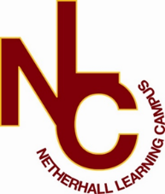

Teacher of Citizenship
Fixed term (12 months)
Applicant Welcome Pack




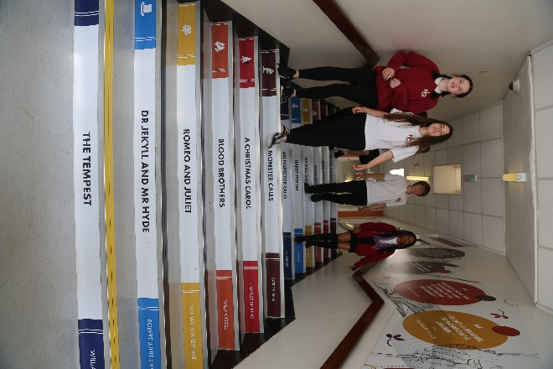

“Success for All”
OUR VISION

At Netherhall Learning Campus our standards and priorities are driven by having the highest of expectations that deliver for all student regardless of their context or starting point. This is underpinned by an unwavering commitment to our vision of ‘Success for All’
Our expectations allow all students to engage within a positive learning environment which in turn has created a Campus that allows all students to make progress. We believe that prioritising good attendance, good behaviour, strong engagement and having high expectations that all children and young adults are able to overcome barriers and become active learners that will go on to benefit society.
The foundations of the Campus’ strength are built on our strong traditions of personalised pastoral care that ensures the climate for learning is calm, well-ordered and secure. We value every student equally and aim to provide a safe and supportive environment. We are aware students have different needs and as a Campus we are committed to ensuring that every student has the opportunity to succeed. This is achieved by providing a broad, balanced and innovative curriculum that offers an excellent mix of inside the classroom and outside the classroom opportunities to learn. We will also offer a range of interventions when needed so that no student is left behind.
The calm, ordered and secure environment allows the Campus to offer a wide range of enrichment activities which students are actively encourage to participate in.
We want our students and parents/carers to feel valued members of the Campus community, we can only achieve this by working together. We value the input from parents to help the Campus with its work. We aim to engage parents as much as possible through regular reporting, parent’s evenings and regular parental contact. We can only succeed if we are united in our efforts.
We aim to encourage creativity, enterprise, teamwork, personal responsibility and leadership skills in all students. We want all students to develop a “can do” attitude that will prepare them for adult life and employment. Our aim is that every student who leaves the Campus at 16 or 18 has a place at college, university, an apprenticeship or a job.

Michael Kent
Principal
About the Campus

Netherhall Learning Campus consists of four schools, covering the full age and ability range from 3 – 19 years, each with its own distinctive ethos; each with its own individual identity and each catering to the specific needs of its students. Whilst the four schools are linked by a common philosophy and by common expectations, each school has its distinct and own characteristics that offer all students a continuous journey from Early Years entry through Key Stages 1 to 4 and beyond to Key Stage 5 via the Studio School. We are made up of a diverse community, yet we are all Netherhall.

A continuous journey
Pupils may join any of the schools at any time. Regardless of the stage at which they start to attend, all students will experience the unique benefit of an education that has been planned by specialist teachers for all stages of a child’s learning journey.
A common standard and expectation of dress, behaviour and standards of presentation:
- All students, regardless of age, are expected to observe common rules of courtesy, respect, honesty and reliability.
- Uniform is the same across the Campus.
- From the start of their school career, all pupils are expected to arrive on time and with the correct equipment.
- Work is always to be presented to the best of the pupils’ ability and books are to be respected and kept in good condition.
A recognition of the importance of parents and carers as partners in the learning journey of our children. A dedicated community team works across the campus to:
- Work with parents to help support their children.
- Encourage greater parent and carer participation in school.
- Support adults who may have had a career break, back into learning and into the workplaces.
High quality teaching
- Teachers across the campus meet regularly to share ideas and good practice.
- They share their expertise and help identify and meet the needs of pupils with special aptitude in their subject area.
Innovative curriculum development
- The curriculum is jointly planned by specialist teachers across the Campus to prevent unnecessary repetition and stalling of progress at change of school.
- Creativity and opportunities for artistic and musical development are actively promoted and encouraged.


Netherhall St James C of E (VC)
Infant and Nursery School
Rawthorpe Lane, Rawthorpe
Huddersfield HD5 9NT
01484 226601
infants@nlconline.org.uk
View map


Netherhall Learning
Campus Junior School
Rawthorpe Lane, Rawthorpe
Huddersfield HD5 9NT
01484 300080
juniors@nlconline.org.uk
View map


Netherhall
High School
Netherhall Avenue
Huddersfield HD5 9PG
01484 382140
info@nlconline.org.uk
View map


The Creative & Media
Studio School
Netherhall Avenue
Huddersfield HD5 9PG
01484 382140
cmss@nlconline.org.uk
View map


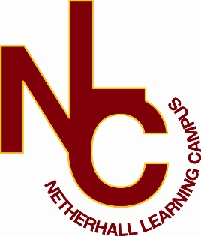

Letter from the Heads of School

Dear Applicant,

Welcome and many thanks for your interest in the vacancy at our school. This information pack will provide you with an outline of the role for which you are considering applying and I would encourage you to undertake further research into our school and its community to make sure this is a role in which you can make a significant, positive impact on the lives of our students. Additionally, it needs to be the right place for you to develop professionally and to be happy in the next stage of your career.
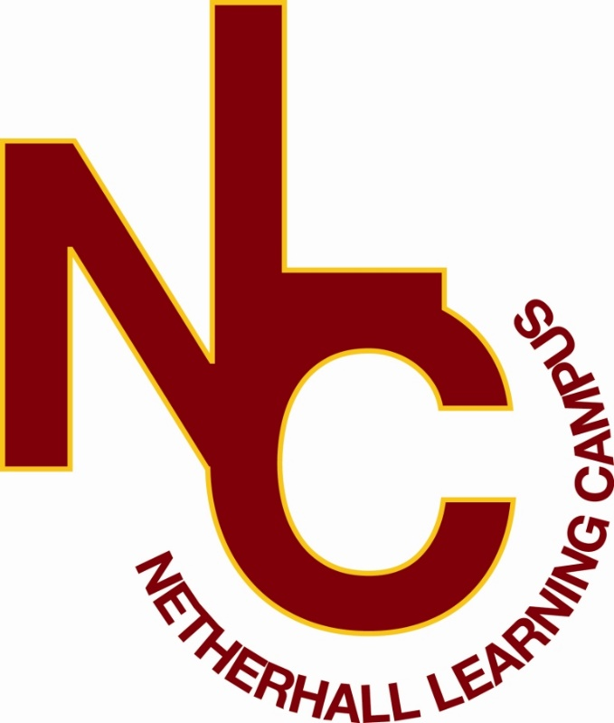
Our ethos of ‘Success for All’, caring for each other and achieving excellence, underpin everything that happens in our school. I believe education should have a positive impact on all students and that Netherhall is the right place for this to happen. We have the highest expectations of all our students in every area of school life. Our school is a caring, nurturing and ordered community with an atmosphere of calm and purposeful learning. Students are treated as individuals and we recognise and celebrate different abilities, aptitudes and interests and believe that everyone can develop through dedication and hard work. We aim to create an enjoyment for learning and a resilience that is essential for achieving excellence. We work hard to ensure every young person is happy, safe and successful – a credit to themselves, their family and Netherhall. We aim high.

A culture of excellent teaching and learning is at the heart of everything at Netherhall Learning Campus and it isn’t just for students; we invest heavily in the continuing professional development of all our staff to improve the student experience. Success is not down to one thing but needs some key ingredients: strong classroom practice, an appropriate and personalised curriculum, rigorous tracking and monitoring of progress, commitment and positive behaviour for learning from students and support from home. These coupled with a love for learning and a passionate belief that all can achieve are crucial so that every student can be the best that they can be.

We look forward to welcoming you into our school community.
K McGrath |  | 
Kirsty McGrath | Zoe Lowe | Heather Johnson
Head of I&N School | Head of Junior School | Head of High School

“Success For All”

Information
Thank you and welcome for taking the time to read this pack.
Netherhall Learning Campus High School is a place where every student is valued and success is a shared goal. As the head of this vibrant learning community, it would be my pleasure to introduce you to a school that is dedicated to fostering a nurturing environment where students not only achieve academically but also grow as individuals.
Our vision is clear: Success for All.
We believe every student has the potential to excel and we are committed to providing the tools, opportunities, and support needed to turn that potential into reality.
Our key values of ready, respectful, and resilient are the pillars that support our vision. They are not just words; they are the standards by which we live and learn every day.
Being 'Ready' means our students come prepared to engage with their education, equipped with the curiosity and the drive to learn.
'Respectful' reflects our commitment to creating a community where everyone is valued and differences are celebrated.
'Resilient' describes our shared determination to overcome challenges and view setbacks as opportunities to learn and grow.
At our school, students don't just learn; they thrive, gaining the knowledge, skills, and characteristics essential for reaching their full potential. We are dedicated to preparing our students for the next stage of education and the workplace, ensuring they leave us not just with qualifications, but with the confidence and capability to navigate the future.
We are very proud of our school and the dedicated team that we have who work tirelessly hard to provide the best opportunities for the young people in our care. We would welcome every opportunity to celebrate the success of this with you.
We look forward to welcoming you in person to Netherhall Learning Campus High School, where your journey towards success could begin today. Together, we will strive to make your experience here one that is filled with learning, growth, and success.
If you would like further information, or to visit, prior to completing your application Please contact our school office and our team will be more than happy to support you with this request.

Mrs Heather Johnson,
Head of School

If you would like to be considered for the post, please complete the application form in full, alongside a letter of application, no more than two sides, outlining your relevant experience to date and the contribution you feel you could make to our school.
Please be assured that we take the time to read and consider all applications we receive. However, it is not possible to give feedback to candidates who have not been shortlisted.
We are committed to safeguarding and promoting the welfare of children and young people we expect all our staff to share our commitment. Further information regarding our safeguarding approaches can be found on our website. The successful applicant to this post will be subject to an enhanced DBS check and other pre-employment checks before the appointment is confirmed. Please note CVs will not be accepted.

Position: Teacher of Citizenship
Contract: Fixed term – 12 months
Salary: MPS/UPS
Start date: February 2026
Closing Date: Monday 1st December 2025 at 12pm
Interviews: w/c 8th December 2025
Completed application forms should be returned to: admin@nlconline.org.uk
For a tour of the school, please contact admin@nlconline.org.uk

Joining Netherhall Learning Campus
- Netherhall Learning Campus High School is committed to developing all staff within their roles and creating opportunities for further career progression
- Pension – Every employee has access to the Teachers’ Pension Scheme or West Yorkshire Pension Fund.
- Emotional Wellbeing Support via Employee Healthcare Service including Care First a free confidential counselling service.
- Wellbeing Benefits include annual flu vaccination, staff gym and exercise classes
- Cycle to work scheme
- Corporate gym membership – as a Kirklees employee you are entitled to the corporate rate at all Kirklees Active Leisure gyms
- Vivup - discounts across hundreds of the UK’s high-street and online retailers
- Totum Pro – NUS card for professionals

Job Description
Key Focus:
- To work with the Subject Leader in maximising students’ academic development and achievement in the Department by taking responsibility for intervention. This will be finalised in discussion with the successful candidate according to their interests and areas of strength/development.
- All staff are fully expected to contribute to the shared objective of ‘Success for ALL’ and to the overall achievement of Netherhall Learning Campus High School Priorities
- Our central purpose is to help our students realise their academic potential. We believe every young person has the potential to succeed and devote ourselves to improving student achievement, through an unceasing focus on learning and teaching and student support.
- Our young people are challenged to achieve through high expectations within a “you can do it culture”.
- We aim at all times to build aspiration, inspire and motivate our students so they have the opportunity for greater choice in life.
Teaching Duties and Responsibilities:
- To be a subject specialist.
- Use a variety of teaching strategies, which involve planned formative assessment and active learning strategies.
- Ensure lessons are differentiated for the individual needs of students.
- Seek to ensure the interests of students are engaged and sustained through provision of clear structure for lessons, maintaining pace, motivation, and challenges.
- Encourage students to think and talk about their learning, develop self-control and independence, concentrate, persevere, and listen attentively.
- Work actively to create an ethos that promotes equality, celebrates cultural and academic diversity, and ensures the inclusion of students of all abilities, including those with special educational needs.
- Plan and work in accordance with subject area course outlines and examination specifications.
- Display sound knowledge and understanding of their subject area.
- Establish good relationships that promote the achievement of learning, whilst maintaining a purposeful and positive atmosphere in the classroom.
- Set the learning in the context of what has gone before and make it clear what it is intended to achieve.
- Monitor and intervene when teaching to ensure effective learning and maintain a safe environment in which students feel confident.
- Self-evaluate teaching critically to improve effectiveness.
- Keep full attendance records sending electronic class attendance data promptly.
- Plan and prepare lessons and schemes of work in accordance with school policy, ensuring a variety of learning opportunities for the development of key skills.
- Maintain individual records of student experiences and achievements in the lessons taught by you and use data to inform future planning.
- Prepare, implement, and monitor Individual Learning Plans for students in accordance with school policy.
- Lead the class team to ensure collaborative working for the benefit of the students.
- Work collaboratively with colleagues, parents/carers, educational psychologists, therapists, social services, and other outside agencies who may be involved with students for whom you have a responsibility.
- Have a thorough awareness of, and regard for, the confidential nature of many aspects of school information relating to individual students.
- Co-operate with colleagues to ensure the achievement of the aims of the school.
- Promote positive student behaviour in line with school policies.
- Assess academic performance in the light of previous achievement to enhance the value-added results of all students.
- Assess how well learning outcomes have been achieved and use them to improve specific aspects of learning and teaching.
- Assess and record students’ progress systematically and keep records to check work is understood and completed, monitor strengths and weaknesses, inform planning and recognise the grade/level at which the student is achieving.
- Set sufficient work for formal assessment, such that students understanding can be regularly checked and so that students can be fully prepared for the demands of public examinations and/or coursework.
- Mark, monitor and return work within a reasonable and agreed time span providing constructive oral and or written feedback that clearly indicates strategies for improvement – as such that students are very clear as to how to move specifically to the next grade/level.
- Attend parent’s evenings according to the school calendar to keep students’ families and/or their carers informed about their progress.
Other Responsibilities
- Take part, as required, in meetings in relation to the curriculum and organisation of the school.
- Participate in arrangements for professional development as outlined in the school development plan or identified through the appraisal process and take responsibility for own development.
- Ensure the activities in which students are engaged are conducted in a disciplined, safe and healthy environment and in line with school policy.
General Responsibilities
- To be an ambassador for the school.
- To model the core values of the school in your professional life and to promote and develop the school’s vision, ethos, aims and objectives.
- To establish a culture that promotes excellence, equality, and high expectations for all students.
- To respond professionally to unplanned situations, crises, and emergencies whenever they arise to ensure the safety and efficiency of staff and students of the school and to maintain good discipline.
- To attend meetings with external agencies and organisations.
- To foster and support extra-curricular activities in the interest of the school community e.g. school productions, concerts, sports activities, trips, and excursions.
- To take on additional responsibilities as directed by the Headteacher and/or SLT link.
Whole-School Organisation, Strategy and Development
- Make a positive contribution to the wider life and ethos of the school.
- Participate in NLC daily duty rota.
Health and Safety
- Promote the safety and wellbeing of students and help to safeguard students’ well-being by following the requirements of Keeping Children Safe in Education and our school’s child protection policy.
- Look after children who are upset or have had accidents.
Professional Development
- Help keep their own knowledge and understanding relevant and up-to-date by reflecting on their own practice, liaising with school leaders, and identifying relevant professional development to improve personal effectiveness
- Take opportunities to build the appropriate skills, qualifications, and/or experience needed for the role, with support from the school.
- Take part in the school’s appraisal procedures.
Personal and Professional Conduct
- Uphold public trust in the education profession and maintain high standards of ethics and behaviour, within and outside school.
- Have proper and professional regard for the ethos, policies and practices of the school, and maintain high standards of attendance and punctuality.
- Demonstrate positive attitudes, values and behaviours to develop and sustain effective relationships with the school community.
- Any other reasonable duties as requested by the Line Manager, Headteacher or member of the Senior Leadership Team that is not specified in this job description.
- Respect individual differences and cultural diversity

Person Specification
To be assessed through application (A), interview (I), references (R) and Admin Check (AC)
CRITERIA  Teacher of | ESSENTIAL OR DESIRABLE | HOW AND WHEN MEASURED *A/I/R/AC
QUALIFICATIONS
A Degree  A Subject Specific Degree  Qualified Teacher Status  Evidence of CPD and further qualification professional study  Relevant subject qualification | E  D  E  D  D | A/AC  A/AC  A/AC  A/I  A/I
EXPERIENCE
Experience of delivering outstanding outcomes both through your own teaching and through support for and working with others  Successful delivery of KS3 and KS4  Proven excellence as a classroom teacher to GCSE level  A recent history of outstanding examination results  Experience of extending learning outside the curriculum | D  D  D  D  D | A/I  A/I  A/I/R  A/I/R  I
KNOWLEDGE, SKILLS AND ABILITIES
Current knowledge of how to build a successful, knowledge rich curriculum, for all topics at both key stages  Ability to analyse and use assessment and data in pupils’ learning to raise standards  Current knowledge of strategies to raise standards of T&L  Excellent oral and written communication skills  Good IT skills which benefit pupils and the efficiency of the faculty  Good knowledge and understanding of the local community | E  D  E  D  E  D | I  A/I  I  I/R  I  I
LEADERSHIP AND MANAGEMENT
Be able to motivate, support and inspire trust in others  Be able to participate in a shared vision  Be able to work successfully as part of a team  Be an effective decision maker and problem solver | D  D  E  D | A/I/R  A/I/R  A/I/R  A/I/R
PERSONAL ATTRIBUTES
To act with the utmost integrity at all times  Contribute to the ethos of the Campus  A highly professional approach to their work, including commitment to ensuring excellent standards of behaviour at all times  The ability to motivate and inspire students  Excellent communication skills  A passionate desire to make a difference and raise achievement for all  Ability to establish good working relationships and effective teamwork  Willingness to support pupils in extra-curricular activities  Be committed to equal opportunities  To uphold all aspects of safeguarding  Ambitious to develop career beyond this point  Be willing to consent to apply for an enhanced disclosure and barring service check | E  E  E  E  D  E  E  D  E  E  D  E | R/I  I  R/I  R/I  R/I  I  R/I  I  I  A/I/R/AC  I  A/AC

