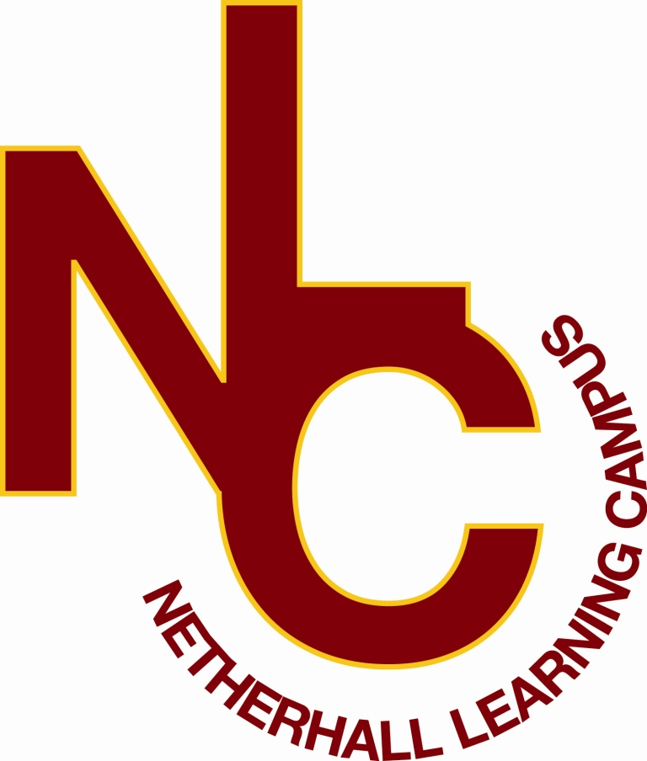
NETHERHALL
LEARNING CAMPUS
JUNIOR SCHOOL

Principal: Mr. M Kent
Head of School: Mrs. Z Lowe
Rawthorpe Lane
Huddersfield
HD5 9NT
Tel: (01484) 300080
Email: juniors@nlconline.org.uk

“Success For All”

26th September 2019

Dear Parents and Carers,

At Rawthorpe Junior School we strive to provide a safe learning environment for all children. Due to some of our pupils suffering with life-threatening nut allergies, we are going to be a NUT FREE SCHOOL.
If someone has a nut allergy it is not just eating nuts that can cause a severe reaction, just being touched on the skin by someone who has had nuts or even a product containing nuts, can trigger an anaphylactic shock ( this can cause severe breathing and swallowing difficulties).

We have staff trained in school to administer auto injectors (an injection of adrenalin) which is required immediately if someone has a severe reaction.

We cannot have nuts in school in any form and we are asking for your support and help by not giving children nuts or nut products in their packed lunches. We do recognise that many foods are labelled as ‘may have been produced in a factory handling nuts and cannot guarantee to be nut free’ and there can be no guarantee with all food products.

Please ensure that you do not provide nut products in lunch boxes or sent in as snacks. For example:
- Peanut butter sandwiches
- Chocolate spreads – there are other nut free products available
- Cereal bars
- Some granola bars
- Cakes that contain nuts
- Biscuits/cookies that contain nuts
- Satay based food

I am sure you recognise the importance of us all taking the time to check the products and packaging to help us stay nut free and protect our children who have these severe allergies. I know if this was your child you would want us to help in any way we can particularly with a life threatening condition.

Please be aware that if a member of staff notices a child eating a nut based product, they will politely remove the product and explain to the child why this has been done. A message will be sent to you to explain what has happened and to remind you of our expectation to stay nut free to help keep all of our children safe.

If you have any questions, please do not hesitate to contact school to speak to Miss Hudson, Mrs Clarke or Miss Lowe.

